Avon Grove Library
April 2024 Programs
Facebook.com/AGLibrary @avongrovelibrary
LOCAL HISTORY SPEAKER SERIES
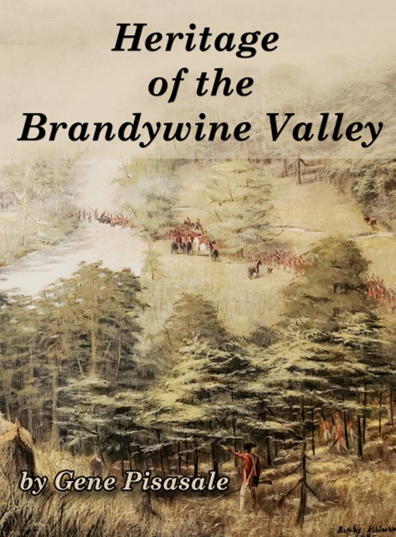
Author Gene Pisasle
“Heritage of the Brandywine Valley”
Wednesday, April 10, 6:30 PM

Monday | Tuesday | Wednesday | Thursday | Friday | Saturday
1  Fiber Arts Group  6-7:30pm | 2  9:30 & 11 AM  Toddler Tuesday | 3  10-11:30 AM Fiber Arts Group  3 PM Teen Gaming Club | 4  10 AM Preschool Storytime | 5  10AM Sensory Storytime | 6  11 AM PAWS for Reading*
8*  Inside of library closed for carpet replacement  April 8-12  Fiber Arts Group  6-7:30pm | 9  9:30 & 11 AM  Toddler Tuesday  Inside of library closed | 10  10AM Stories & Stretching  10-11:30 AM Fiber Arts Group  3 PM Dungeons & Dragons  6:30 PM Local speaker series: Gene Pisasle  Inside of library closed | 11  10 AM Preschool Storytime  Inside of library closed | 12  10 AM Crafty Kids Corner*  Inside of library closed | 13  10 & 11 AM STEM Saturday*
15  Fiber Arts Group  6-7:3opm | 16  9:30 & 11 AM  Toddler Tuesday | 17  10-11:30 Fiber Arts Group  3pm Teen Gaming Club | 18  10 AM Preschool Storytime  6:30 PM Book Club for Adults  6:30PM Chess Club* | 19  10 AM Sensory Storytime | 20
22  Fiber Arts Group  6-7:30pm | 23  ELECTION DAY  NO PROGRAMS | 24  10AM Stories & Stretching  10-11:30 Fiber Arts Group  3 PM Dungeons & Dragons | 25  10 AM Preschool Storytime | 26  10 AM Crafty Kids Corner* | 27  11AM Make Your Own Mother’s Day Card
29  Fiber Arts Group  6-7:30pm | 30  9:30 & 11 AM  Toddler Tuesday
Program Highlights
* = Must register online at https://ccls.libcal.com/calendar/AvonGrove/ (QR code below)
All programs are free unless otherwise noted. Full program schedule available at www.avongrovelibrary.org.
Family/Children’s Programs
Toddler Tuesday Storytimes: Tuesdays at 9:30 and 11AM, Library Activity Room
Preschool Storytime: Thursdays at 10AM, Library Activity Room

Sensory Storytimes (Ages 3+ and their caregivers)
April 5 & 19, 10-10:45 AM
Our Sensory Storytime aims to create a shared experience through engaging stories, songs, fingerplays, & interactive sensory play. This unique program is designed with sensory needs in mind, but we welcome everyone to participate.

Crafty Kids Corner* (Ages 3+)
April 12 & 26, 10-11 AM
Join us for festive Winter Crafts! Explore colors & themes while creating age-appropriate crafts. Registration required.

School Age & Teen Programs
For more info about these programs, scan the QR code below & click on the event for details & to register, if required.

STEM Saturday* (Grades K-2) Saturday, April 13, 10 AM
STEM Saturday* (Grades 3-5) Saturday, April 13, 11 AM
Explore, imagine, create, and PLAY with us in this hands-on makerspace program. Registration required.

Adult Programs
Local History Speaker Series: Gene Pisasle April 10, 6:30PM
Avon Grove Library partners with the West Grove Museum. Author Gene Pisasle will discuss his latest book "Lost: Chester County Pennsylvania." He charts the county's lost history and shares his knowledge of its may historic landmarks.

Avon Grove Library Fiber Arts Group Mondays 6-7:30pm & Wednesdays 10-11:30am
Whether it be knitting, crochet, embroidery, cross stitch, or similar, all are welcome to join and work along with others.

Due to carpet replacement, the inside of the library will be closed from Monday April 8th-Friday April 12th. Holds and museum passes may still be picked up during regular business hours, and materials can be dropped off. All scheduled programs will continue.

.